Operating System (CS301)

Assignment - 1

**U19CS012**

1.) Create the directory and files for the following structure and write single UNIX command for each given instruction:

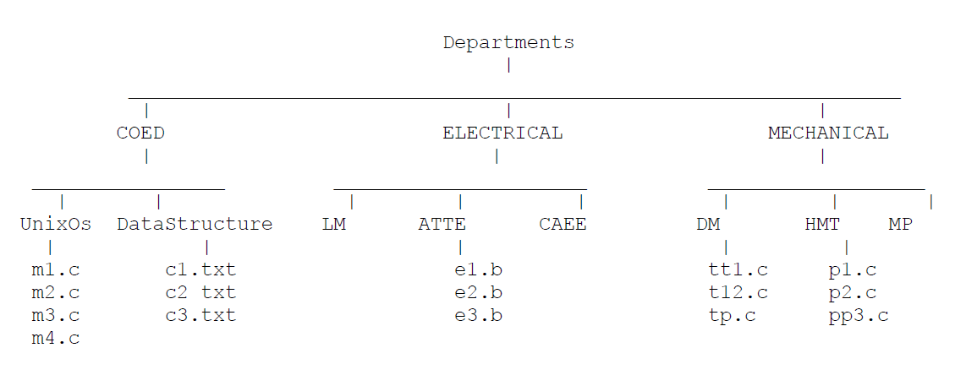

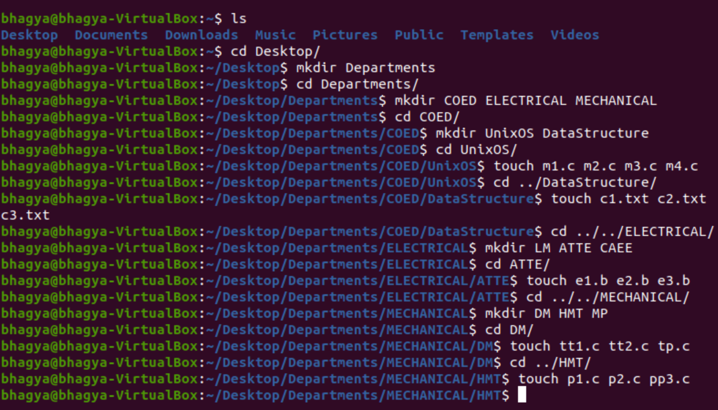

1. Display the entire structure.

**Command:**

**sudo apt-get install tree**

**cd ../../**

**tree**

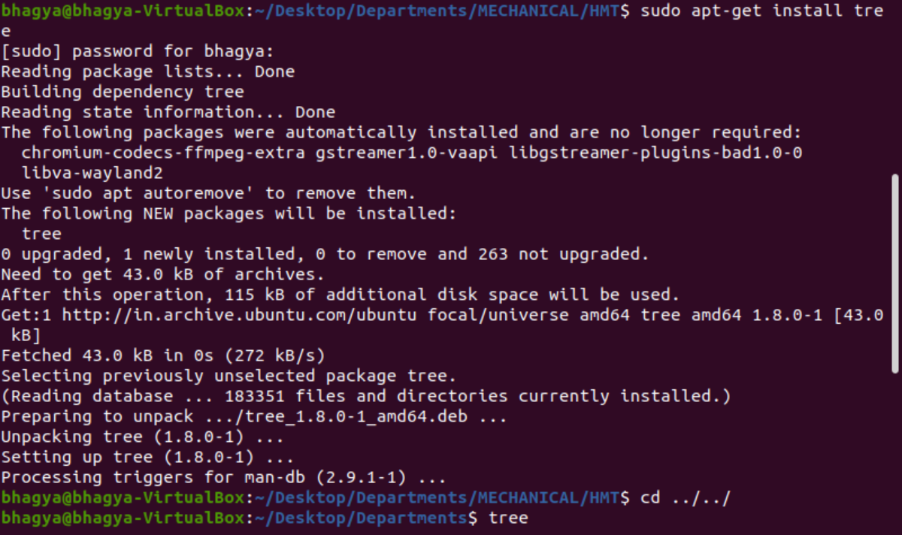

**Tree in Next Page**

**Output:**

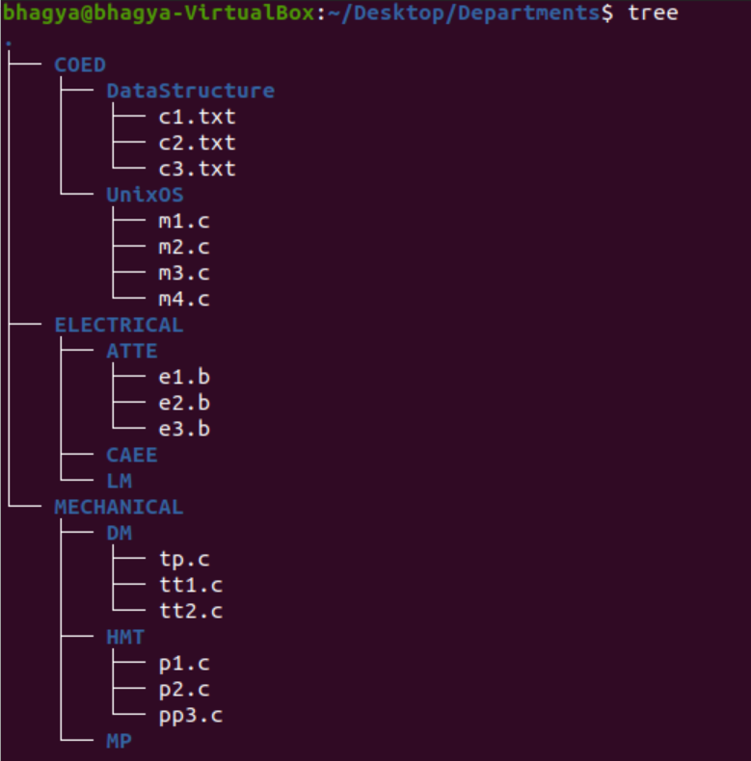

2. Assume that you are in Departments directory. Write a command to copy m1.c of UnixOs directory to DM directory.

**Command:**

When only the directory name is specified as a destination, the copied file has the same name as the original file.

**cp COED/unix0S/m1.c MECHANICAL/DM/**

**OR**

**cp COED/unix0S/m1.c MECHANICAL/DM/m1.c**



**Output:**

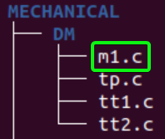

**cp Src_file Dest_file**

If the 2nd file doesn’t exist, then first it creates one and content is copied to it. But if it existed then it is simply **overwritten** without any warning. So be careful when you choose destination file name.

3. Assume that you are in Data Structure directory. Write a command to copy file e2 from ATTE to LM.

**Command:**

**cp ../../ELECTRICAL/ATTE/e2.b ../../ELECTRICAL/LM/e2.b**



**Output:**

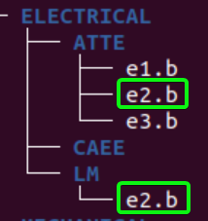

4. Assume that you are in HMT directory. Copy all files of HMT directory, having 3 characters filename, to MP directory.

**Command:**

**cp COED/unix0S/m1.c MECHANICAL/DM/**



**Output:**

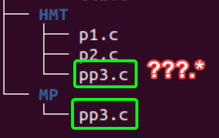

5. Assume that you are in Departments directory. Copy all files of COED directory having first character "c" in name to CAEE directory.

**Command:**

**cp COED/*/c*.* ELECTRICAL/CAEE/**

**Output:**

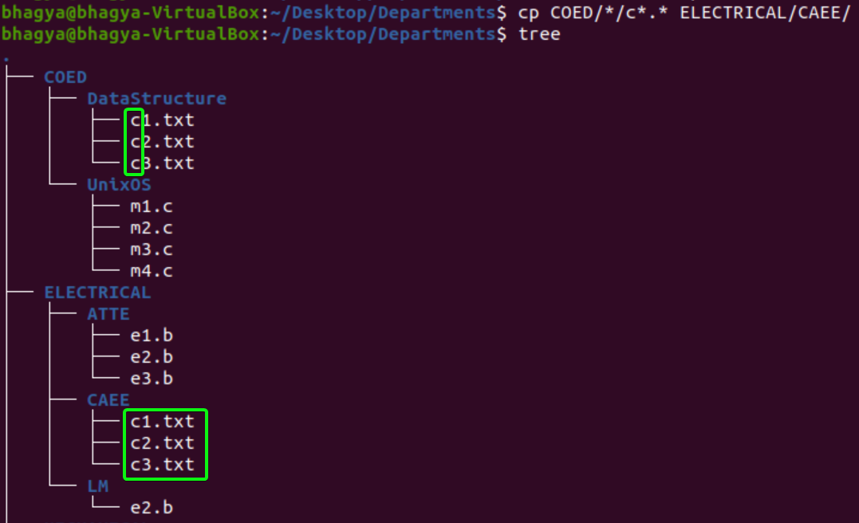

6. Change the name of file tp.c of DM to ctp.c.

**Command:**

**mv tp.c ctp.c**

If the destination file **doesn’t exist**, it will be created. In the above command **mv**simply replaces the source filename in the directory with the destination filename (new name). If the destination file **exist**, then it will be **overwrite** and the source file will be deleted. By default, **mv**doesn’t prompt for overwriting the existing file, so be careful!!

**Output:**

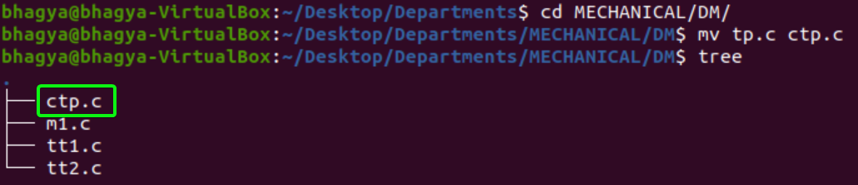

7. Rename e1.b to e1.c.

**Command:**

**mv e1.b e1.c**

**Output:**

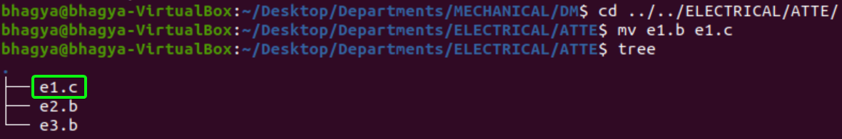

8. Delete file having second char. p of HMT directory.

**Command:**

**rm ?p*.\***

rm stands for **remove** here. rm command is used to remove objects such as files, directories, symbolic links and so on from the file system like UNIX. To be more precise, rm removes **references to objects** from the filesystem, where those objects might have had multiple references (for example, a file with two different names). **By default, it does not remove directories.**

This command normally works silently and you should be very careful while running **rm**command because once you delete the files then you are not able to recover the contents of files and directories.

**Output:**

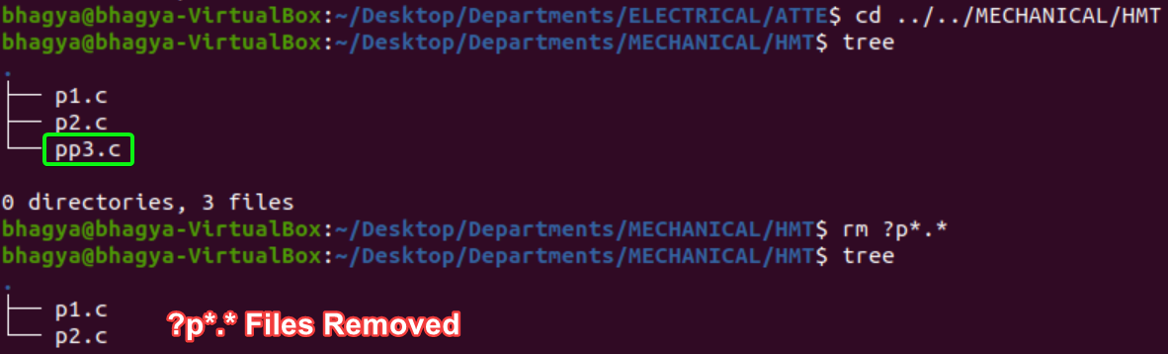

9. Assume that you are in ELECTRICAL directory delete m1.c of ~~DM~~ UnixOs directory.

**Command:**

**rm ../COED/UnixOs/m1.c**

**Output:**

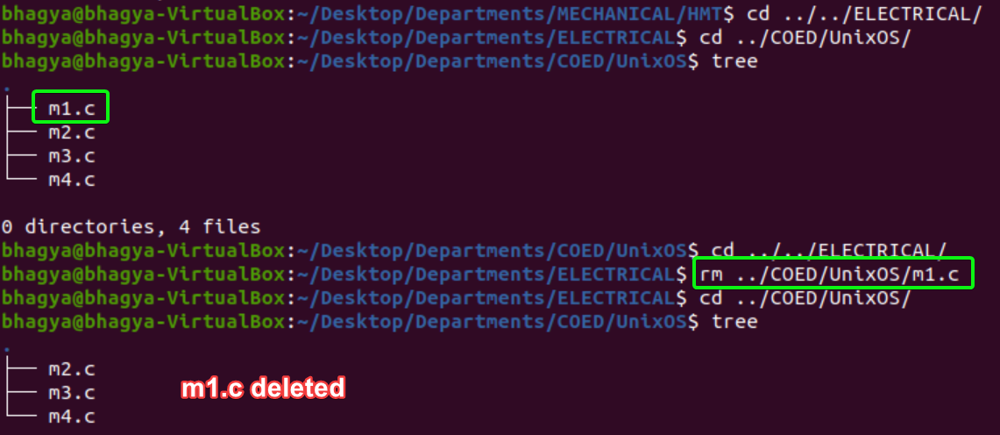

10. Assume that you are in MECHANICAL directory. Delete all files of Unix Os directory having 2 characters in filename.

**Command:**

**rm ../COED/UnixOs/??.\***

**Output:**

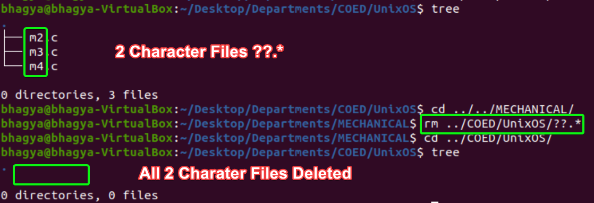

11. You are in MP Directory, display the current directory path.

**Command:**

**pwd**

**pwd** stands for **P**rint **W**orking **D**irectory. It prints the path of the working directory, starting from the root.

**Output:**



12. Remove UnixOs directory

**Command:**

**rmdir UnixOs**

**Output:**

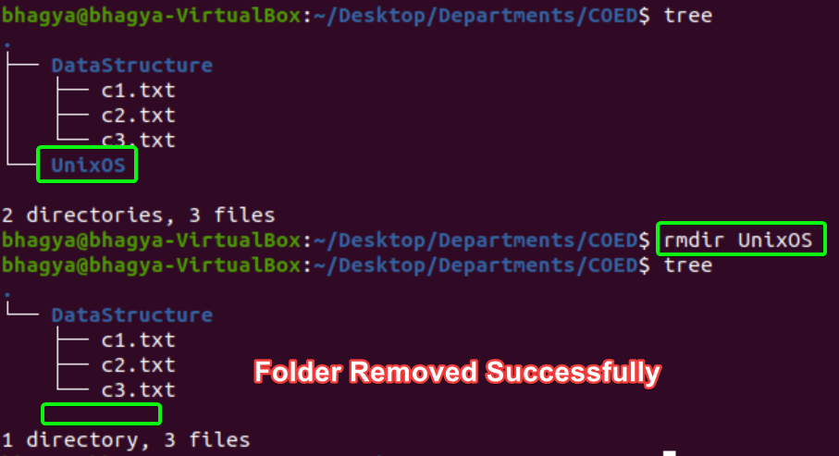

13. Display current date and time.

**Command:**

**date**

**Output:**



14. Display content of file c3 with page break.

**Command:**

**less c3.txt**

**Output:**



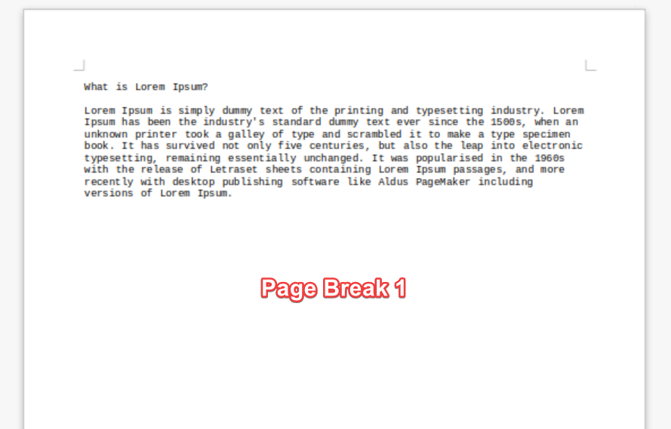

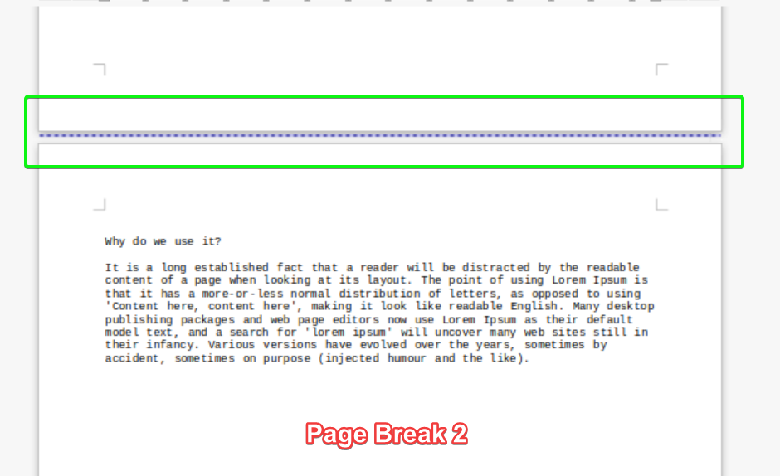

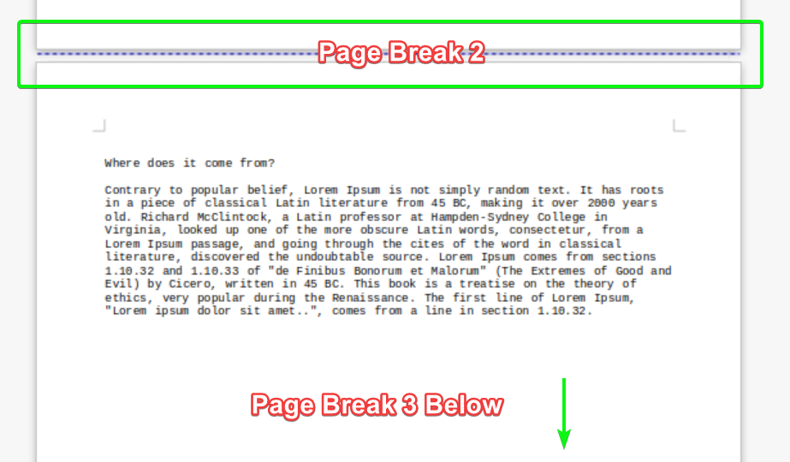

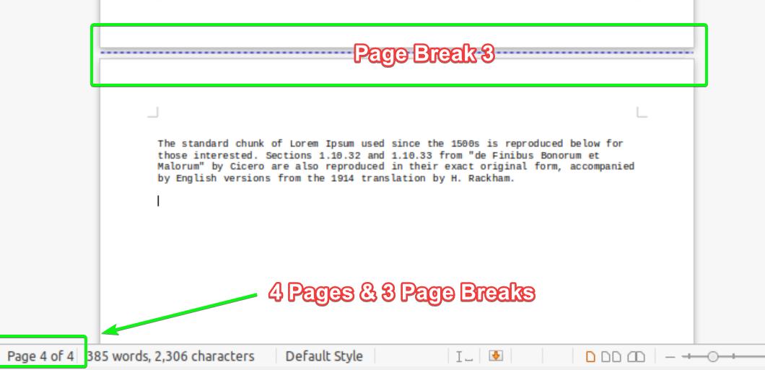

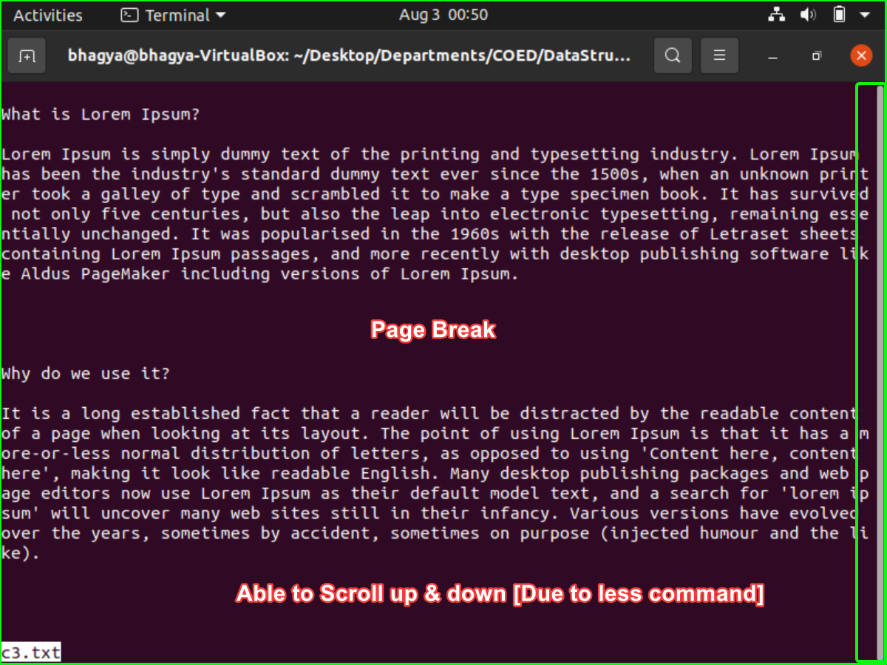

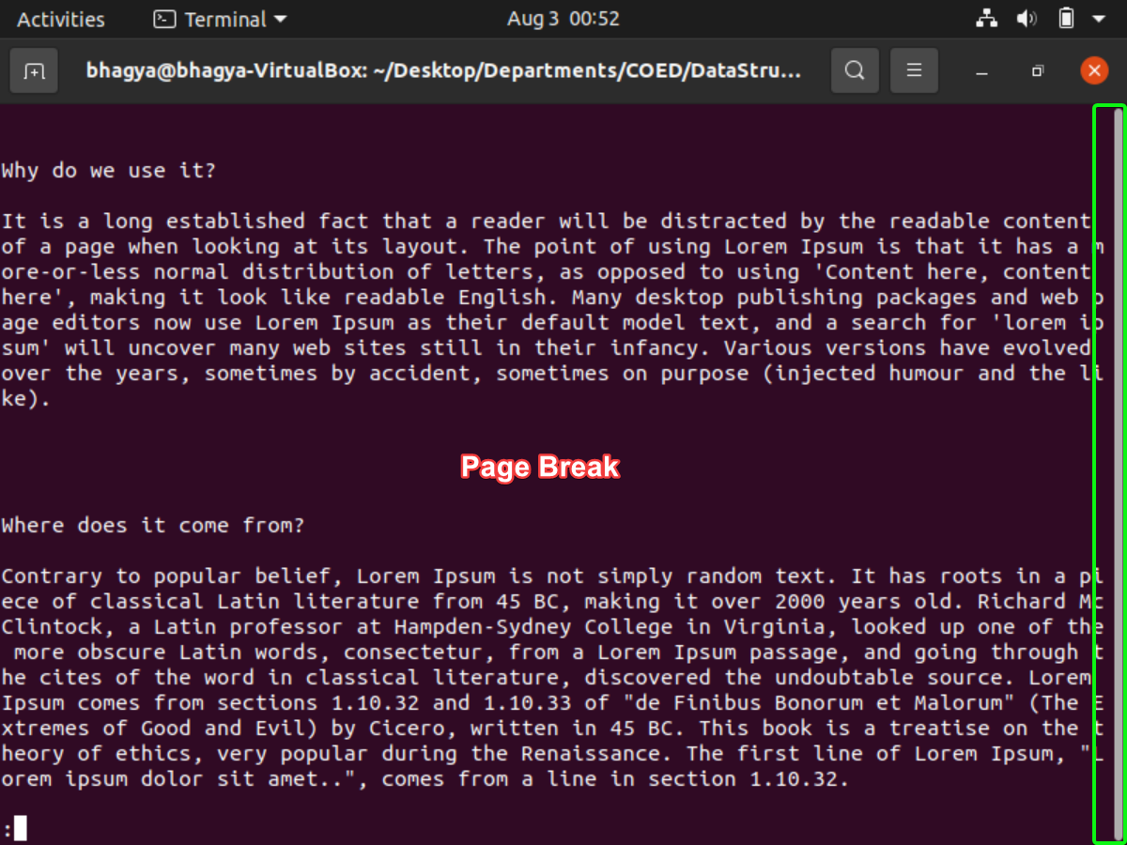

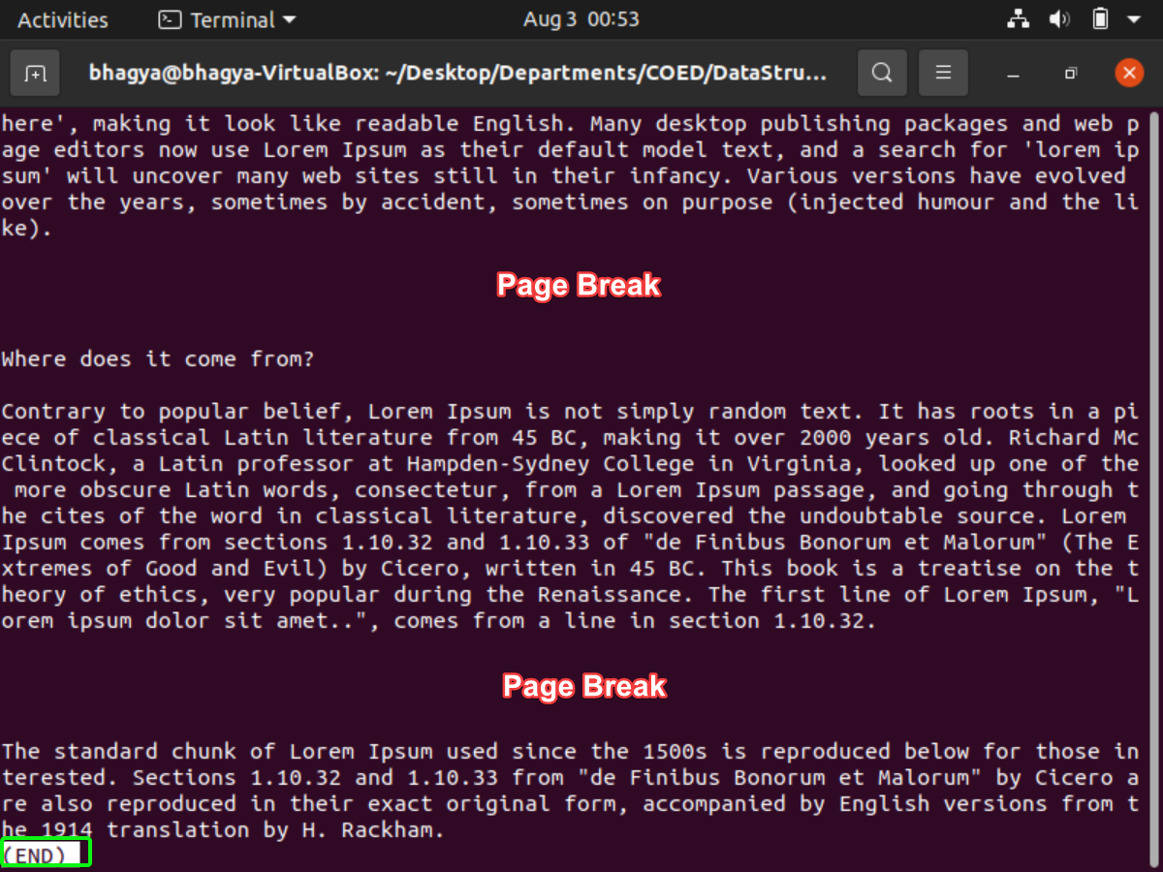

15. Change the permissions of file p2.c to different modes possible

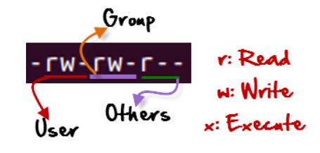

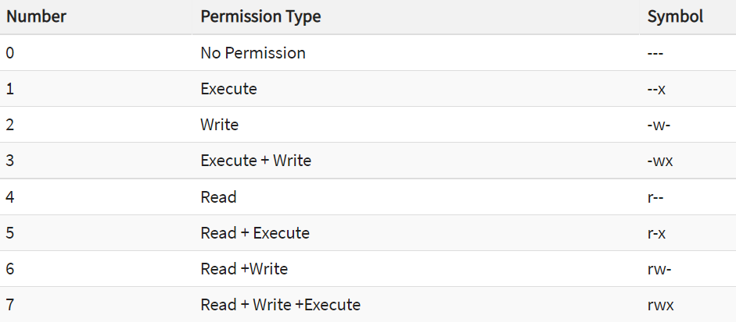

**Command:**

**To View Permission**

**ls –l**

**To Change Permissions**

**chmod 764 file_name**

**Output:**

A.) Checking Current File Permissions



B.) chmod 764 and Checking Permissions Again

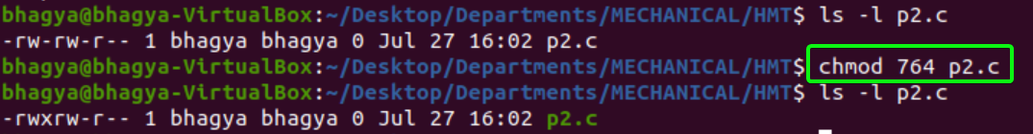

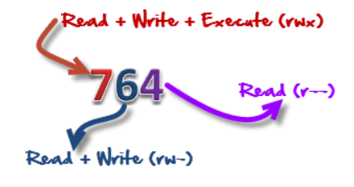

'764' absolute code says the following:

* Owner can read, write and execute
* Usergroup can read and write
* World can only read

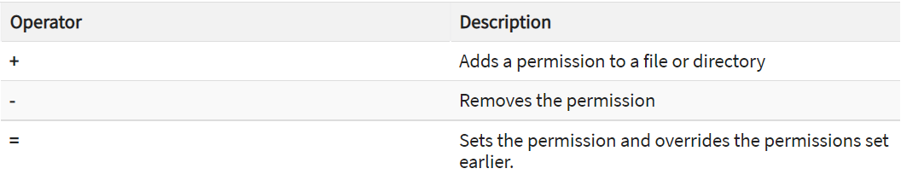

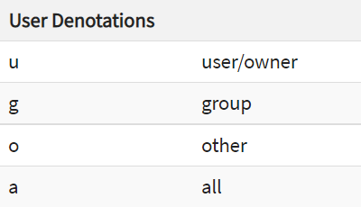

C1.) Current File Permissions



C2.) Setting Permissions to ‘Other’ Users



C3.) Adding ‘Execute’ Permissions to ‘Group’



C4.) Removing ‘Read’ Permissions from ‘user/owner’



16. You are in root directory, display the all filename of MP directory.

**Command:**

**To Navigate to Root Directory**

**cd /**

**To List all the Files on MP Folder**

**ls /home/<your username>/Desktop/Departments/MECHANICAL/MP**

**Output:**

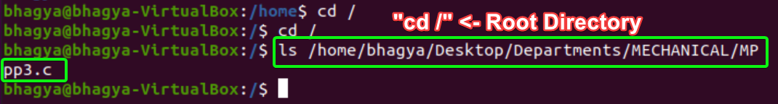

17. Clear all the screen on which u work.

**Command:**

**clear**

**Output:**

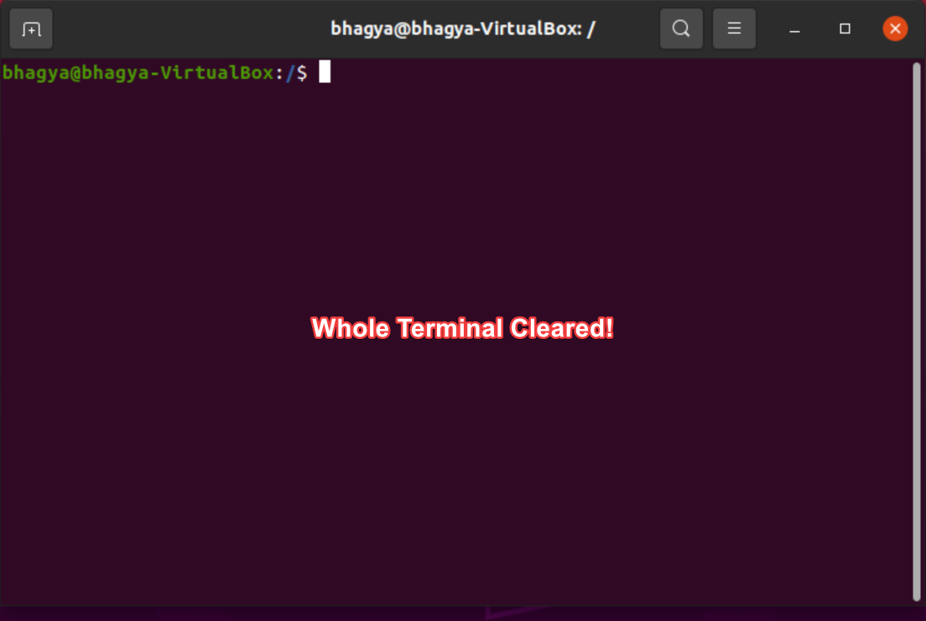

SUBMITTED BY:

**U19CS012**

BHAGYA VINOD RANA